“BUSINESS CANVAS”

 | Submitted By
1. | Kevin Jacob | 141170107027
2. | Surabhi Modak | 141170107026
3. | Piyush Singh | 141170107060
4. | Rendell Josephe | 141170107016

In fulfillment for the award of the degree

Of

BACHELOR OF ENGINEERING

In

COMPUTER ENGINEERING



Neotech Institute of Technology,

At Virod , Harni-Virod Road,

Vadodara-390022

Gujarat Technological University, Ahmadabad

May, 2018

i

CERTIFICATE

Date:

This is to certify that the dissertation entitled “Business Canvas” has been carried out by Kevin Jacob , Surabhi Modak , Piyush Singh , Rendell Josephe under my guidance in fulfillment of the degree of Bachelor of Engineering in COMPUTER (8th Sem) of Gujarat Technological University, Ahmedabad during the academic year 2017-18.

Guide:

Head of Department

Mr. Yogesh Prajapati

Prof. Vipin Nagar

Assistant Professor

Neotech Institute of Technology

Neotech Institute of Technology

ii

TABLE OF CONTENT
TITLE | PAGE NUMBER
KEY PARTNERS | IV
KEY ACTIVITIES | IV
KEY RESOURCES | IV
VALUE PROPOSITIONS | IV
CUSTOMER RELATIONSHIPS | V
CHANNELS | V
CUSTOMER SEGMENTS | V
COST STRUCTURE | V
REVENUE STREAMS | V

iii

    - Key partners

        - The people can register their own vehicles and earn revenue.

        - Vehicle agency can provide vehicles and earn revenue.

        - Garage and vehicle parts can provide auto parts.

        - Alpinestars rynox gears can sponsor riding gears for rent as well as sell them on our website.

- Key activity

        - Renting vehicles (cars and bikes)

        - Riding gears

        - Parts of the vehicles

        - Trip organizing

        - Travel blog

  - Key resources

      - Getting sponsored vehicles from premium segment vehicles

      - Garage parts dealers

      - People registering their own vehicles

  - Value proposition

        - A vehicle rental system which include basic as well premium segment vehicles

        - Can rent as a taxi as well

        - Providing necessary gears for riders

        - Trip organizing

        - Travel blog

iv

  - Customer relationship

      - Through emails

      - Phone calls

      - Push notifications

  - Channels

    - Social media sharing

    - Advertisements

  - Customer segment

      - People who are in a need of a vehicle.

      - Tourists

      - Passionate people fulfilling their desires by riding a premium segment vehicle.

      - People who are new to the city.

  - Cost structure

      - Buying a domain

      - Employee salary

      - Advertisement

      - Commission for vehicle owners

- Revenue stream

      - Adsense

      - Advertisements

      - Commission

      - Sponsorship

v

The Business Canvas Model

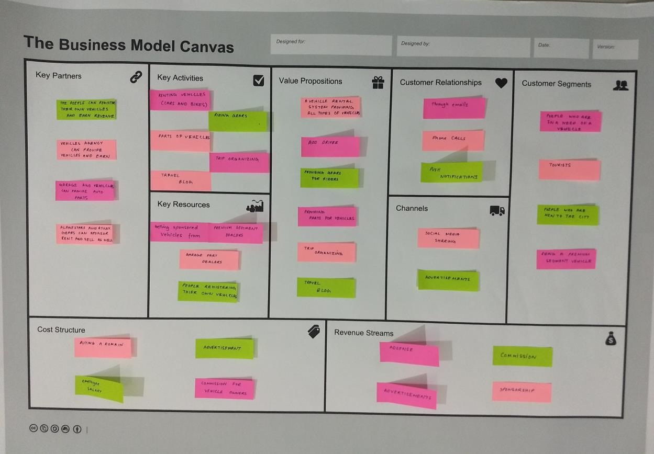

vi

